Tell me about your self

My name is Saurav Ajabe, I did graduation from Pune university

After that I got chance to work as a software test engineer at cognizant

During this 2 year, I have worked in various technologies such as

Database testing, ETL/BI, BIG DATA, API web service along with data set atomisation using python script

Q) what are your role and responsibilities there?

Ans = I am involving in request analysis

Test scenario design

Test case preparation

Review test case

Test case execution

Defect analysis (here the interviewer will ask that are you involved in defect analysis)

Ans = I mean to say defining the priority and identifying the root Couse analysis and reporting

And client interaction meeting daily meeting scrum meeting, stand-up calls, client meeting

Q) Tell me about your project?

Ans = I am working in the telecom vertical

Telecom:

There are types of communication

1. Satellite: mobile

Satellite

tower

Mobile

Mobile

1. Landline: Home

Local exchange wan Shivaji Nager

Lan

premises

Lan= local area network 180 km

Mumbai

Verticals In telecom

Lan = local area network

Wan= wide area network

Man= Metro area network

Service provider: Airtel, Idea, Vodafone

Q) you are client are service or network provider?

BSNL provides service as well as network

Ans = both

Network provider

Two types of providers are there

* Service provider
* Network provider

Device/ network equipment

* Switch: a network swich foreword data packets between devices, switches send data packets directly to devices rather than sending to networks like route does

Physical layer and data link layer and we can also say network layer

* Router: a router is device that connects two or more packet-switched network or subnetwork

Router works on three layers: physical, data link (it checks the mac address), network layer (it checks the IP address)

Function: managing the traffic between these networks by forwarding data packets to their IP addresses and allow multiple devices to use the same internet connection

* Hub:

Manufacturer:

* Cisco
* Fujitsu
* Huawei
* Juniper
* Alcatel-lucent
* Marconi
* Tyco Evo tam

Technology:

Copper: SDH: synchronisation digital hierarchy

Ethernet: fibre optics

WDM: wavelength division multiplex

This are the horizontal

* CRM
* OSS
* BSS
* Mediation

Banking:

* Insurance
* Core banking

Payment:

Credit card

Debit card

Rent

Wages

Interest & profit

OSS workflow:

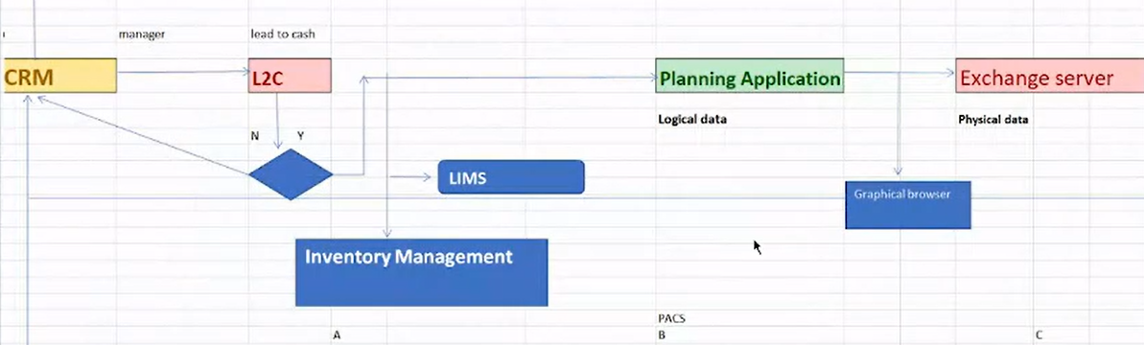

Order processing provision and activation

CRM: CRM is domain and the application name can be different like CBL CRM,

Lead to cash: It is also domain and depend on company the name will change

Inventory management system: here all data related to frequency, plan, MBPS, route, switches

Planning application: or logical data: here the network planning done here with help of inventory management system

Exchange server: a program can only run if the respective hardware is compatible and exchange server is also called as physical server

Service assurance: If their issue in the exchange server then we have to raise the ticket and send to the CRM and then the it will again go through the provision and activation team please modify the network the CRM send this request to OSS engine and make it correct then and then the ticket will remove

Model, frequency, distance, technology this requirement will provide on SRS document

Logical inventory management system (LIMS)

Planning configuration platform:

Exchange server: (physical server)

Requirement: model, frequency, distance, technology

Logical inventory

Management system

Planning coffin platform

Exchange server

A 1350 B C

1350

A = B

B= C that is c = a

1350

Q) what is risk factor?

Ans= planning network

Our main task is to synchronise the logical server data to the physical server

There are two objectives:

* Business objective: inventory system must be synchronised with physical server
* Operation objective: logical server must be synchronised with the physical server

Table involved in the planning and configuration system in the database (logical inventory management system)

Select * from manuf_info

Select * from model_version where manuf_info = “cisco”

Select * from technology

Select * from frequency

Planning and configuration application:

1st page

Model

Manufacturer

Technology

Version

Log in

password

User id

Interview explanation: we receive various types of requirements like the model, how much frequency there must be after that we are going deal with three system that is inventory management system, planning and configuration platform and the physical server the business objective is the logical inventory management system must be integrated with the exchange server and here the risk factor is planning the network, this is the critical area I think

2ns page:

Topologies:

Select * from topologies_info where topologies = ‘standalone’

Swich configuration:

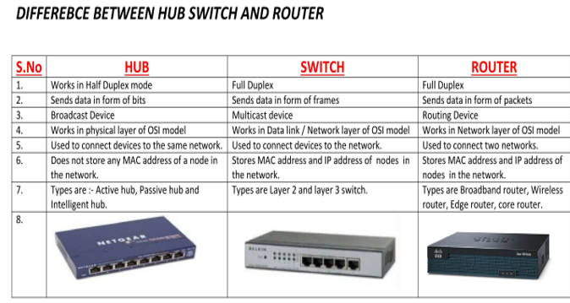

The configuration of logical server must match with the physical server

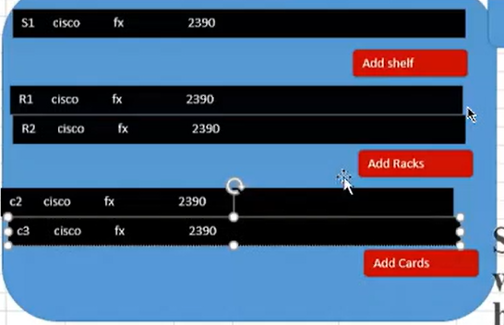

and with help of

select * from racks where manufac_info = ‘cisco’ and model = ‘fx’

after saving the data unique id generated called scheme no (6 digit), if we choose the ring topology then the mux option will enable

Here we to add the shelf, racks, pots as per requirement

@) How many cards are there in one switch

Ans = there are 80 to 130 cards

Types of cards

Gage cards

Fan card

Interface card

CWDM

DWDM

OSS engine workflow:

There is a Shap rate application for exchange server with the help of credential we can log in for example Australian telecom exchange server

After log in we get a white interface of JSP that is java server page of white colour first tab will be shelf and inside it there is rack after selecting the shelf then and then the reck will display from the planning and configuration system the request will be generate with all logical data and then the logical data get synchronised with the physical server in return the physical server will send the response

Schema mapping:

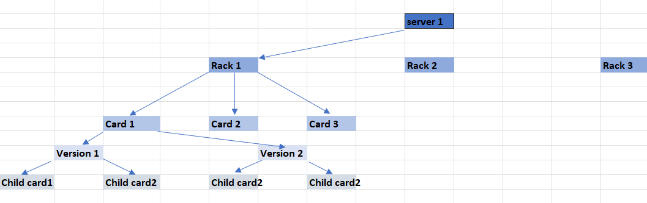

There are two process we are mainly doing that is addition and deletion of data that is dealing and monitoring the schema relationship (object relationship management)

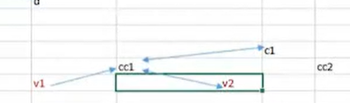

In the deletion process if we delete the child card then there should be the response of child card only if we delete the parent class in physical server then response must countian all class minus parent class

This process is called as XML parsing that is the validation between response and request file

Request file

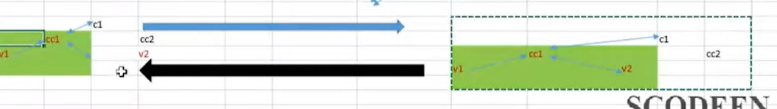

Response file

If the new requirement comes with like we have to implement FX 1305

Suppose if missed to implement the FX 1305 on the logical server then at exchange server it will through an error

The source system is depending on the types of networks

MPLS: multiprotocol level switching

FTTH: fibre to home

V-Lan

Oss engine

Network type

Target database

Type of device

Manufacturer

CRM and BSS end to end workflow:

Generate order processing in CRM

There are various types of products WIFI, fibre, multimedia

Explanation: generally, in CRM we generate an order we receive various types of products

In CRM basically there are Information about the customer then we come across various sates like

Create, amend, modify, delete, cease

The workflow includes account creation, contact information, leads, opportunity, quotation

We once reached the opportunity CRM send the request through web service to the credit score then it will check the credit score of the customer and in response it will send the credit score if it is yes then and then it will go to the next step that is quotation if not then it will stop.

Q) what is credit score?

Ans = it is related to financial and transaction

Once the status quotation gets generated, we run the job and a job is a script compile via Unix, ant then all information is loaded in OSS. Then OSS will response the data is loaded

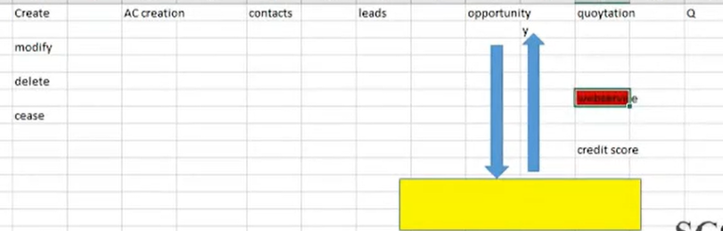

The CDR file comes In the picture it is of two types ASCII (American slandered code for information interchange) and binary format, the CDR file mainly consist of

The phone no of subscriber or calling party or A- party

The receiving phone no or called party or B-party

The starting time of call (data and time)

The call duration

The billing phone no that is going to charge for the call

The identification of the telephone exchange or equipment writing the record

A unique sequence no to identify the record

The additional digit no on the called no to route or charge the call

The disposition of the call whether the call is connected or not

Call type (voice, SMS etc)

The route by which the call entered the exchange

The route by which the call left the exchange

Prepaid non billable

Post-paid billable prepaid rooming billable

In the mediation level data stored in the form of billable and non-billable which is represented by 0 and

Q) which CRM you used while doing your project

Ans= Amdocs CRM, SIBILL CRM, SAP, ZOHO

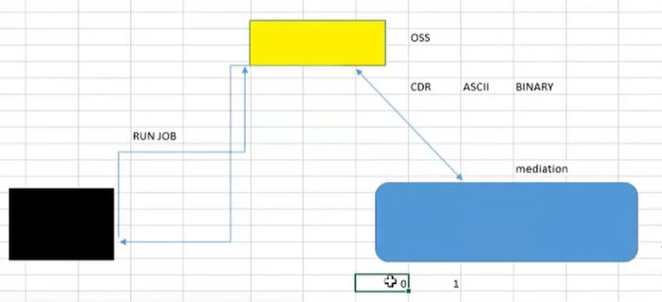

Q) which is engine you are using?

Ans= Amdocs crammer, HP, Nokia

Which mediation tool you are using?

Ans = Ericsson, net cracker

Again, we run the job then data from mediation is get loaded in BSS engine Once the data is loaded in BSS only billable record considered only billable record is move into the BSS engine. There is rating and charging engine where the rating is come from CRM through API webservice then we get tariff plan from CRM, once the rating and charging is taken place the billable data moves into billing system

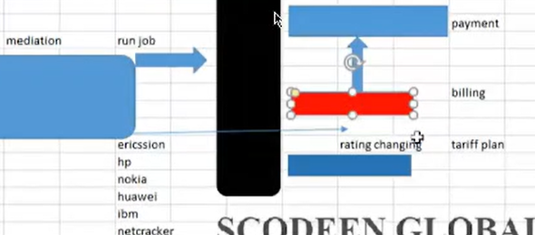

UBS: unified billing system

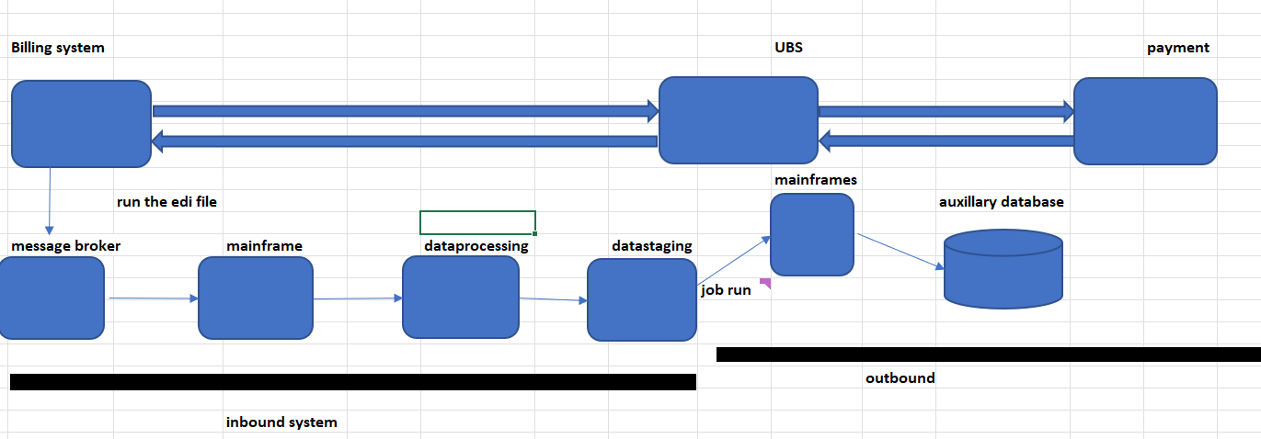

We run the EDI file then data moves into message broker then main frame, data processing, data staging this comes under the inbound system, then data moves into main frames and then into auxiliary database here validation of data is involved

To access the info we have to run the job via Unix there is already provided script we have to just run it with help if Unix tables(script) like job_scan_qr_001 and job_upi_002

After the job run a log file is generated this log file, we again used to evaluate the data

The log file is present in the form of flat file we convert it into Jason format by using Unix

Then atomised with help of python script

==================================================================================

I also involve in complex data set atomisation process, python script using ML and data analytics mechanism

Above explanation is about backend atomisation

And API it is frontend atomisation (web service atomisation)

If there are multiple jobs to run then we use store procedure to run the job at one single time

@) what is store procedure?

Ans = a store procedure is nothing but SQL query or statement which is stored in DBMS so as group it can be reused or shared by multiple program

Key points:

We use BSS in payment system (report analytics)

Source file name: SMS, MMS, VOICE, DATA

We migrate this source file into AWS cloud to improvise the performance and security we stored it in a data ware house

Suppose if we compare Mumbai and Pune city, in this two city electronic related things are mostly used then Mumbai it will be consider as most preferable city this type of information or data is called as train data

Defect management:

Log defect

Q) How much time is required to log the defect?

Ans = 10 – 15 minutes

Q) how much defect get log in one day?

Ans = front end defect 3 to 4 or sometime 5

Backend defect 5 to 6

Hp ALM: HP application life cycle management with latest version

Another comparative tool: mantis, Jira, MTM (Microsoft test management)

Jira is used as agile project management toll

HP ALM

2006 – test director

2008 – mercury

2010 – HP QC

First page:

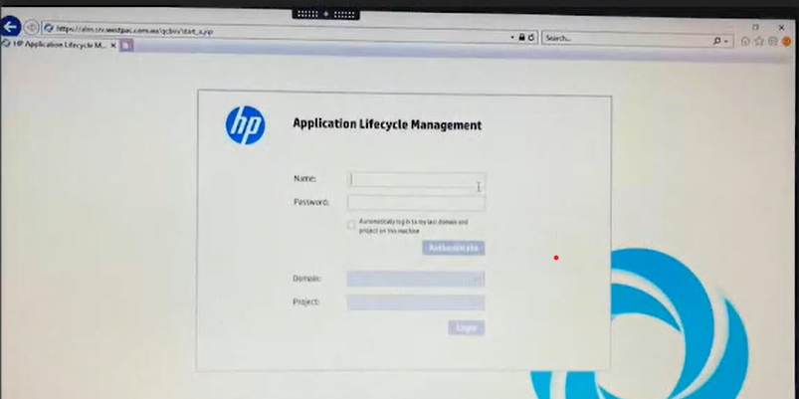

Second page: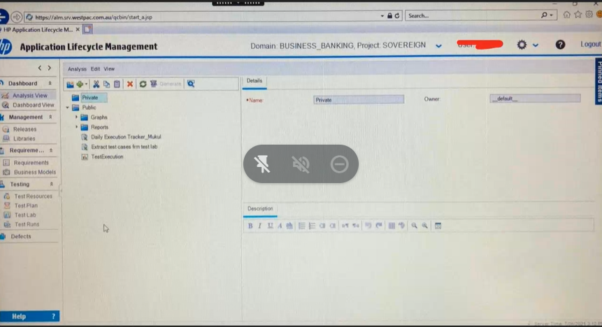

Q) what are the tabs?

Ans=

* Dashboard:

Graphical representation of defect statistics in terms of pi/ bar chart

Defect fix testing

Credit 20 10 10

Debit 30 20 5

* Management (no roll): resource management and release activities along with project plan

It totally handover by project manager

They are two scenarios are there

1. Release: how many employees, how many resource, when there is release, when there will be testing
2. Libraries

* Requirements:

It occurs just before build goes to production

Requirement mapping (traceability matrix)

Traceability matrix: mapping between use case or business condition with test case

* Testing

Test resource: Resource management and task allocation for test team

Test plan: we create test batch or test suite

Q) what is test batch (it is same as function)

Ans = clubbing of interdependent test case

Example:

R3.0_Amazon_Account_Address_Add (it is same as package)

R3.0_Amazon_Account_Address_Add_country

R3.0_Amazon_Account_Address_Add_Custmer_Name

R3.0_Amazon_Account_Address_Add_Mobile_No

This are called as suit

R3.0_Amazon_Account_Address_Edit

R3.0_Amazon_Account_Address_ Edit _Country

R3.0_Amazon_Account_Address_ Edit _ Custmer_Name

R3.0_Amazon_Account_Address_ Edit _Mobile No

R3.0_Amazon_Account_Address_Remove

R3.0_Amazon_Account_Address_ Remove _Country

R3.0_Amazon_Account_Address_Remove_ Customer_Name

R3.0_Amazon_Account_Address_ Remove _Mobile No

R4.0_CanaraBank_Corporate_Login

R4.0.1_Canara_Bank_Corporte_login

R4.0.1_Canara_Bank_Corporte_Password

R4.0.1_Canara_Bank_Corporte_Otp

For what purpose we create batch?

Ans = the main reason behind is that if some defect comes then the whole process will stop there no need to test further function

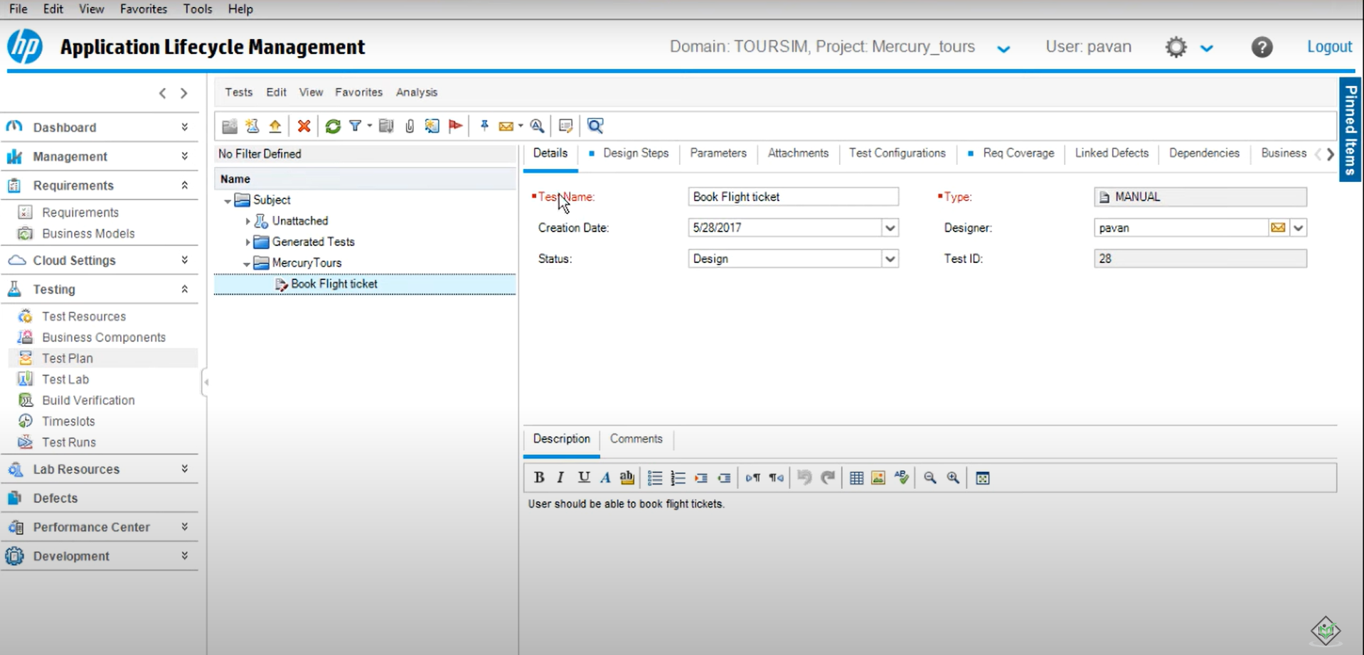

Domain_business_Banking project Sovereign

Here for us the same country but for machine it two different countries

Batch is nothing but function

After right click

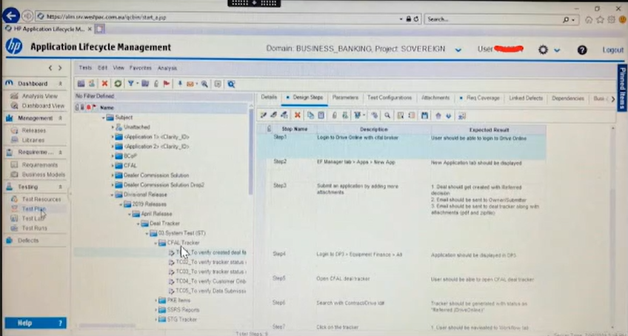

How to add batch?

Ans= right click in subject and add the batch

How to add the test case?

Ans = same procedure right clicks add test case

After clicking the test case

Int Q) why we not use HP ALM while writing test cases?

Ans= due to performance issue some time server will not respond while writing test cases

Test case format:

Test case id description test data priority precondition action expected result



If there any changes due to front end data in the backend then we simply mention yes or no as per

Result that is the database is impacted or not

How to upload test case to HP AML?

Ans = for that we use Excel add in application

Step by step procedure to upload excel test case Into HP ALM

Test plan:

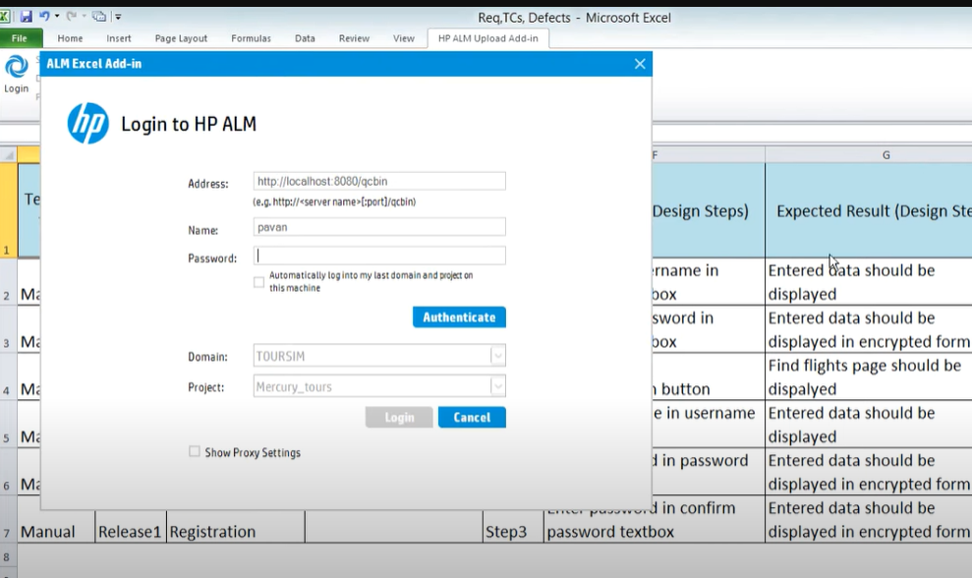

1ST STEP:

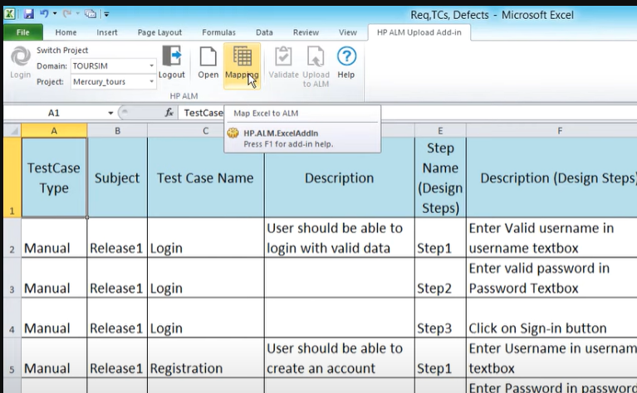

2Nd step:

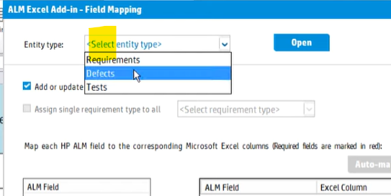

3Rd step:

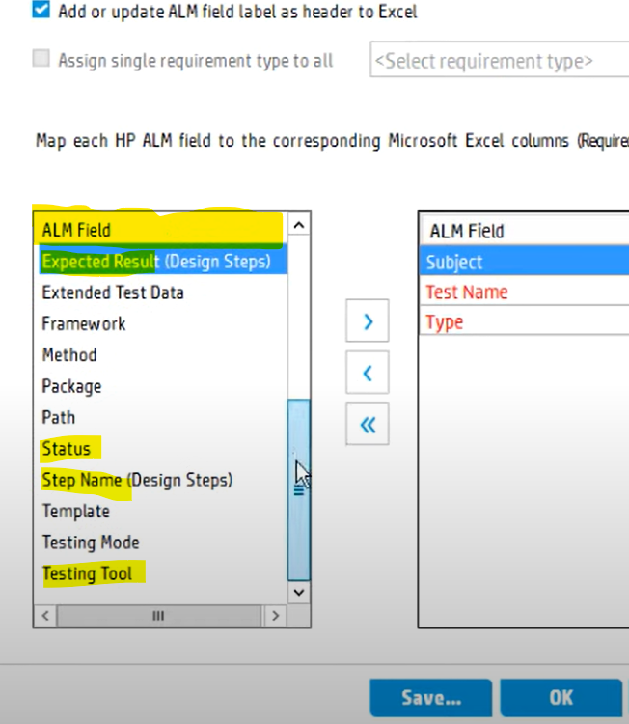

4Th step:

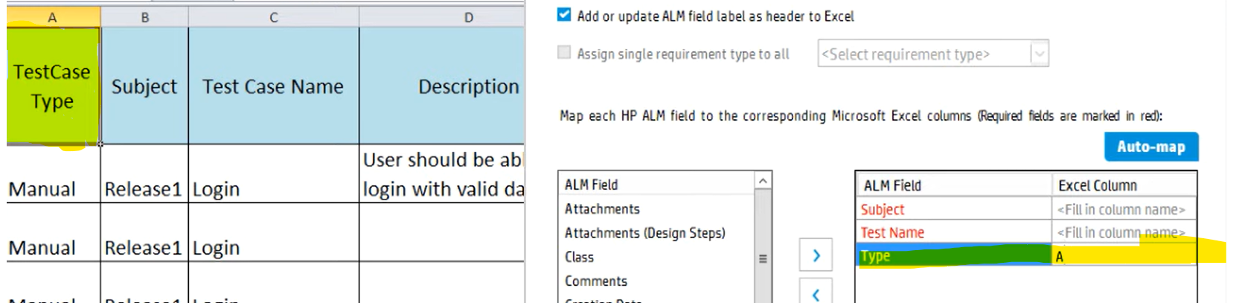

Other way mapping is auto map”

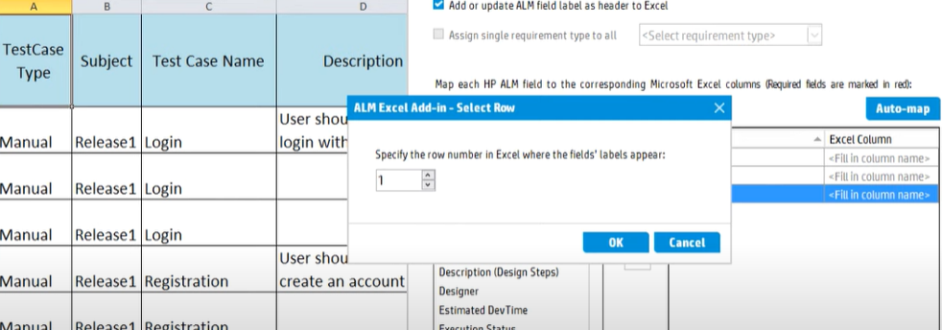

Then last step is validation:

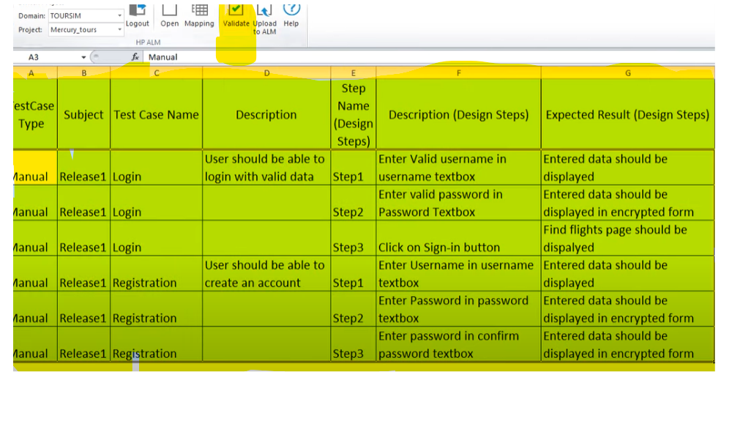

Q) how you upload test case in hp ALM?

Ans = First with help of credential we will log in the hp ALM. Then there are some field like dashboard, management, requirement,

Then by selecting all the data click on validate. It will validate the data can show an successful message after that for uploading we select whole data

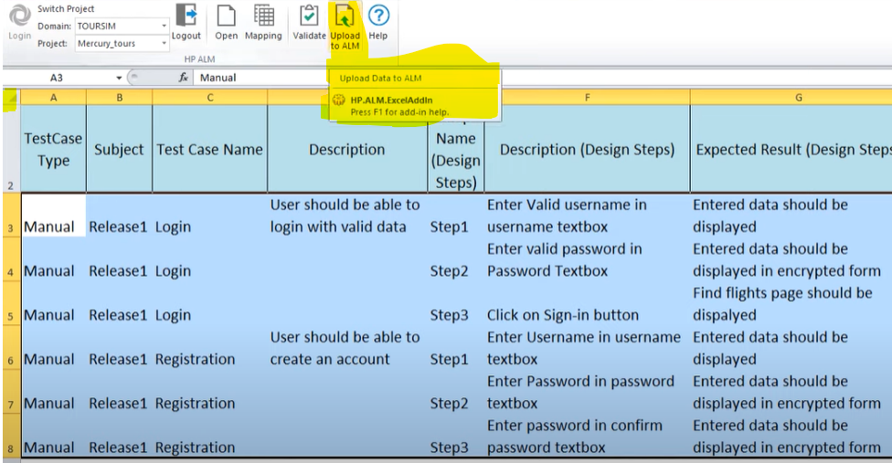

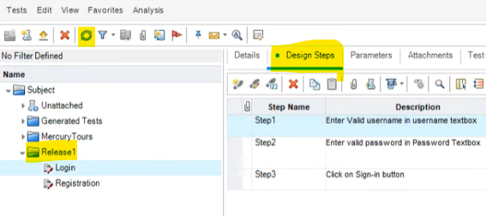

We used to log in with the credential then there are some field like dashboard, management, requirements, testing, lab resource, defects, development

And mostly I am working in testing tab for uploading the test case in the hp ALM I used a excel add in application where I involved in mapping the test cases between excel add in and hp ALM toll

Q) what is the scenario you faced while mapping the test case?

Ans = while mapping the important things are entity type, test name, test type (manual, performance, system, business process, load runner scenarios) and other like creation data, designer

In field mapping tab we can manually map the column or we can use auto map once the mapping done a new row is gen

And one more thing the test name should be as per the excel name

Test lab: test case execution monitors and handling

Execution status

Report generations

Linking defect very- very important

How to move test case from plan?

Ans = here we also copy the test case in similar manner like test case in test plan and after moving this all data to test lab it is called as test plan tree

W have to create same folder structure of test batch, in the right panel test tree plan will be created

=================================================

What test plan in manual testing?

Ans = in test plan there are some components like test case objective, types of testing, exit criteria, entry criteria, environment setup

In HPALM test plan is a type of module where we fecht the test cases, test sets

==================================================

What is test execution status?

Ans =

Pass expected = actual

Fail expected <> actual

There is also other scenario where test execution status is partially pass

Correspond parent function functionality

Descope: out of requirement

Linking defect: every defect has its id in. linking defect test case name with id is attach with linked defect tab it is nothing but a hyperlink

Defect:

Summary:

* R4.0_Amozon_Address_SIT_Add
* ‘Mobile number’ Is accepting Invalid data in ‘Add a new address’ page
* ‘Sub id’ Is not getting generated in Database
* Invalid price data in response File, in NEFT Transaction
* Invalid price data in response File, in CISCO FX 3215 switch
* Request and response file is not getting matched for customer name
* Invalid length of subscriber id in target system
* Source count and target count is not getting matched for ‘Product id’
* defect component

Detected by [Sauravajabe@IBM.COM](mailto:Sauravajabe@IBM.COM)

severity * severity defines how **severely a defect can affect the functionality of the software application**

Priority: it defines how fast we need to fix the defect

Assign to

Q) whom you assign the defect?

Ans = the responsible person from the development team like lead, pm

Closing date

Detected in release R1.0001_2023

Estimated fix time: +24 hours

Planning closing version: 27.0

Project: Order Amazon

Status: very-very important

Target cycle= SIT

Detected on date = system date

Actual fix time

Detected in cycle

Detected in version 26.0

Defect category: functional, UI, design, requirement, environment

Reproducible defect: which appears again and again

Non reproducible defect: we will take a snapshot and mark It as an ‘issue’

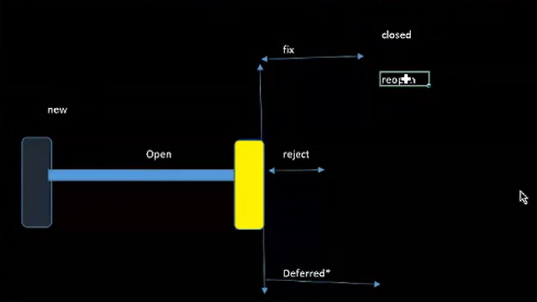

New defect: very first-time defect = Register defect

Open: under analysis stage

Fix: developer agree

Reject:

Deferred: developer agree but fix will be provided in later version due to functional interdependency

Order #500-1651-151 order id is not getting generated

Order id is getting generated twice in database

Order id is not present in ‘Invoice’ during the order processing

Closed defect: no defect existing

Reopen: once we receive the modified build if the defect is still there then we will reopen it

Side defect: here two scenarios will be there

if existing defect gets resolved and any side defect will be there in this case, we will close the existing defect new defect will be raised

if existing defect is closed and any side defect are there for example improper error message, in this case we will reopen the defect with some extra comment related to defect

Q) who is responsible for the status of the defect?

Ans = practically, developer send the statis via mail and we take the responsibility to improvise the process

Severity: criticality of defect with respect to functionality, I mean to say how much the system getting impacted

Priority: importance of defect with respect to customer requirement, I mean to say how the customer is getting impacted

All backend related defect is considered as high-level defect (high severity)

Database, ETL, BI, Big data, System integration [request and response file]

Example:

* request and response file data not matching
* Subscriber id getting generated twice
* ETL: Source and target count id not matching

Low severity and high priority:

Low severity and high priority mean suppose the product id is correct in database but at the front end one hyphen is missing that is high priority but at back end is as per requirement that is low severity there is no impact in software

Account id, application no is not getting display in the encrypted format

Example:

5151111151165 backend

515111115**** frontend

All GUI related defect are considered as low medium defect

Q) how to create new defect?

Ans =

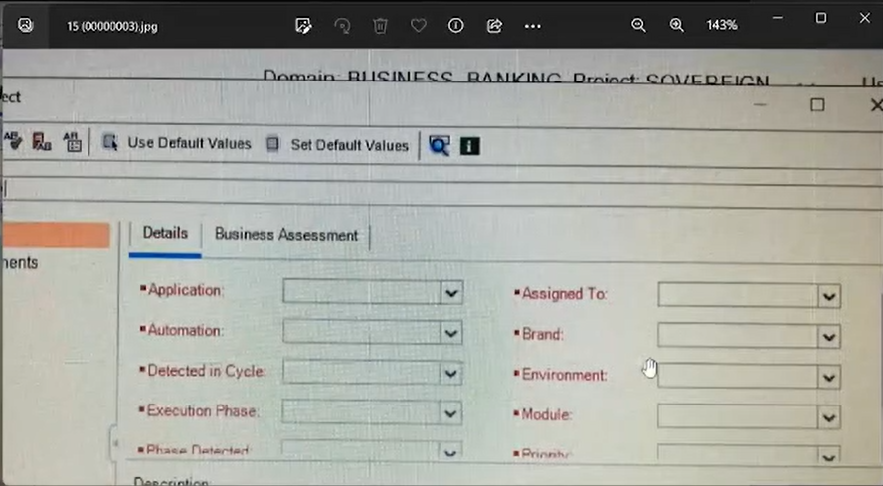

Q) how to write product description?

Ans =

This defect belongs to R4.0_Amazon_Invoice_Invoice generation

Build line 23.0

Navigation:

Step 1st: log in

Step 2nd: enter UID and password

UID

PASS

Step 3rd: Go to order -----invoice

Step 5th: verify order id

Expected result: order id should be present in invoice

Actual: order id not present in invoice

Q) what is defect age?

Ans = gap between defect identified date and closing date

Defect submission:

There are two type transmitter and transmittal

Transmitter

Pm pm

Pl PL

Test engineer developer

Transmittal

Pm

PL PL

Test engineer developer

What would be your approach if developer reject our defect?

Ans =

* I will try to explain him or her with strong reason
* I will discuss with BA
* I will discuss with the client with permission of pm

Defect resolution type

The send resolution type via mail

Fix = developer agree the defect

Deferred: agree but it will fix in latter version

Duplicate: duplicate is not status it is resolution type. It is similar defect

Amit mobile address – defect id 1234

Sumit mobile edit module -defect 1235 it will consider as duplicate defect

To reduce this defect will share among the test team, to improvise the process

Function as design: it means suppose we consider

Price – 60 it is as per client requirement

But in tester perspective how come the price is negative

Software limitation: it means fi we want to download invoice in pdf format but the application that support pdf is not installed in the pc it is called as software implantation that we can call as hardware issue

When would come to know testing is completed

Traceability matrix

Mapping between test with use case/ business condition